



Normalizing a denormalized table for a Bookstore Management System.
LAB MANUAL

Disclaimer: The content is curated from online/offline resources and used for educational purpose only
Normalizing a denormalized table for a Bookstore Management System.
Objective:
To normalize a denormalized database for a Bookstore Management System, ensuring it follows normalization principles up to Third Normal Form (3NF). The objective is to eliminate redundancy, maintain data integrity, and improve query efficiency by structuring the database systematically.
Problem Statement:
A denormalized table for a Bookstore Management System has redundant data and is not in compliance with normalization rules. Normalize this table to follow 1NF, 2NF, and 3NF by:
- Eliminating repeating groups and ensuring atomicity (1NF).
- Removing partial dependencies (2NF).
- Removing transitive dependencies (3NF).
Book_ID | Book Title | Author Name | Publisher Name | Publisher Address | Category | Price
1 | Database Design | Aryan Gopal | TechBooks Inc. | 123 Tech St. | Education | 50
2 | Web Development | Jyoti Chirag | Codebooks Ltd. | 456 Code Ave. | Programming | 40
3 | Database Design | Aryan Gopal | TechBooks Inc. | 123 Tech St. | Education | 50

Requirements:
Software/Tools:
MySQL Workbench, PostgreSQL, or any SQL-compatible RDBMS.
Text editor (e.g., VS Code, Notepad++) for writing SQL scripts.
Skills Required:
Basic understanding of relational database management systems.
Familiarity with SQL syntax and database normalization concepts.
Prerequisite Knowledge:
Functional and transitive dependencies.
Concepts of 1NF, 2NF, and 3NF.

Steps and Procedures:
Step 1: Open MySQL to create the database.
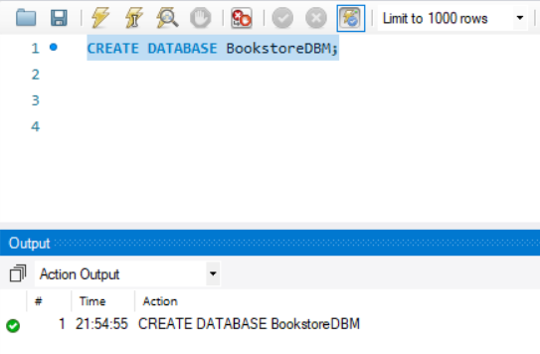
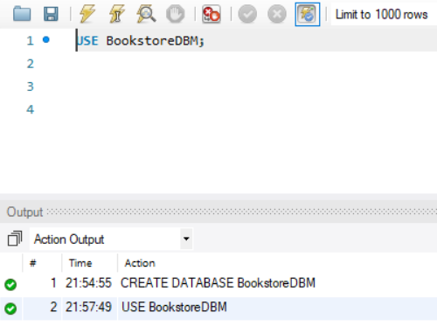

Step 2: Create the Denormalized Table
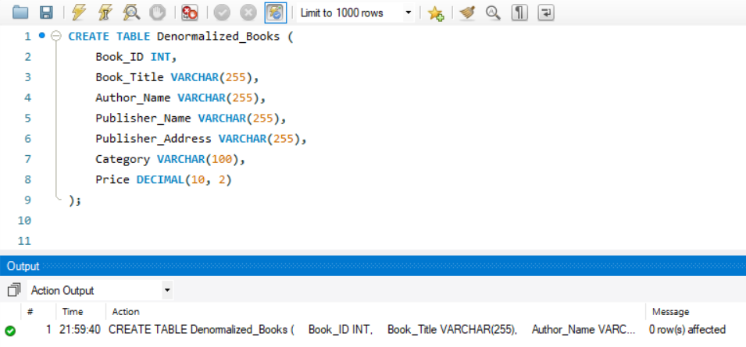

Step 3: Insert values into table
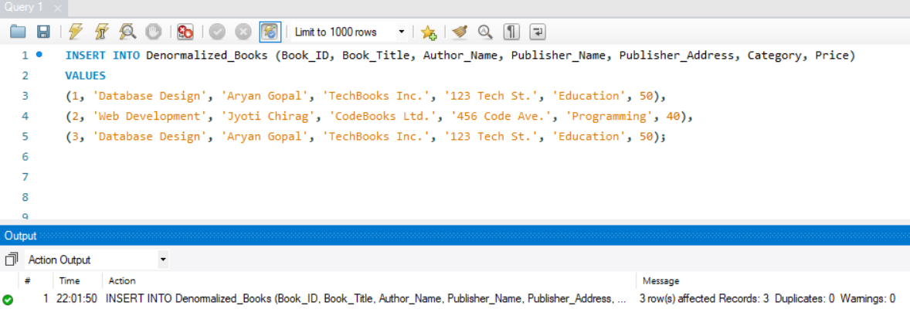

(a) Normalize to 1NF: Normalize the table to First Normal Form (1NF) by ensuring that all attributes contain atomic values. Write the resulting table structure and indicate any changes made.

Step 4: Normalize to First Normal Form (1NF)
To achieve 1NF, we need to:
Split multi-valued columns (Author_Name) into separate rows.
Ensure that each column contains atomic values.
Add a primary key to identify each row uniquely.
Ensure atomicity: Each field should have one value only. (The table already satisfies this condition.)

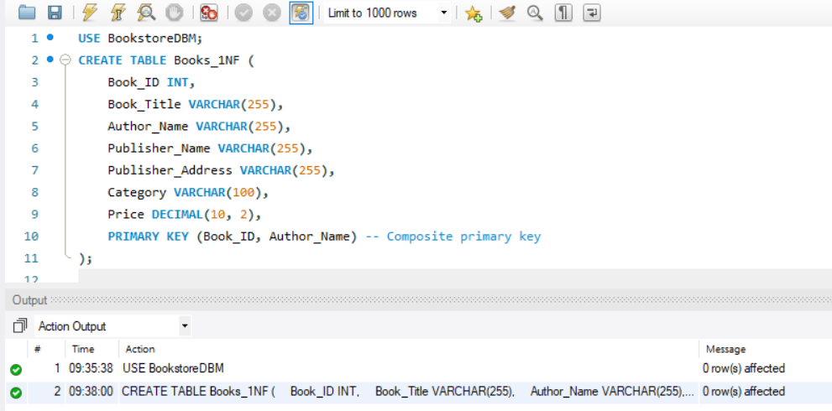

Changes Made:
- Atomic Values: The multi-valued column Author_Name has been split into individual rows.
- Uniqueness: Each row now represents a unique instance of a book and its author.
- Primary Key: The Book_ID along with Author_Name can serve as a composite primary key to ensure row uniqueness.

EDucation”,50.00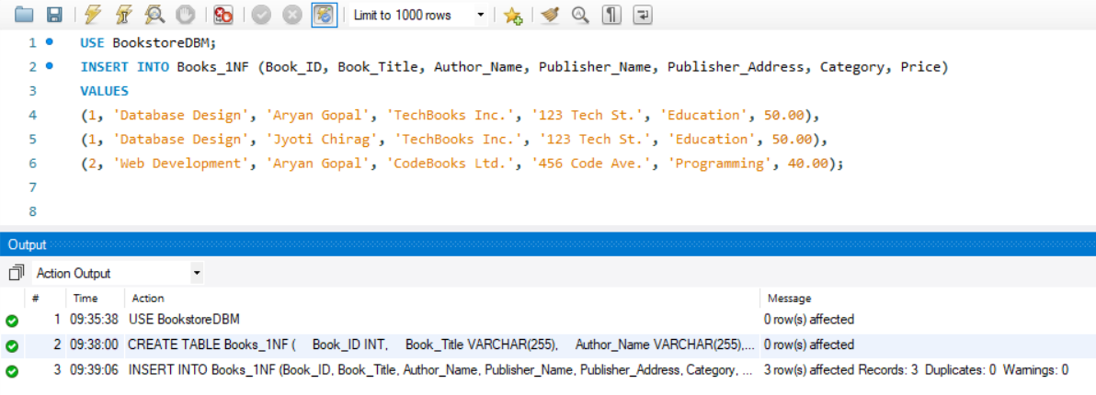

The table now conforms to 1NF:
- All attributes contain atomic values.
- There are no multi-valued columns.
- Each row is unique using a composite primary key (Book_ID, Author_Name).
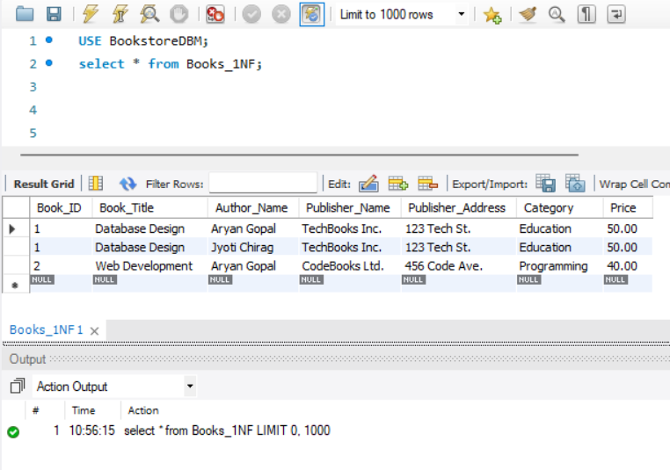

(b) Normalize to 2NF: Further normalize the table to Second Normal Form (2NF). Identify the functional dependencies and explain how you eliminate partial dependencies. Write the resulting tables in 2NF.

Identifying Functional Dependencies
In the 1NF table, the composite primary key is (Book_ID, Author_Name) because each combination of Book_ID and Author_Name uniquely identifies a row. However, not all columns depend on the entire composite primary key.
The following are the dependencies:
Column | Dependency
Book Title, Category, Price | Dependent only on Book_ID (partial dependency).
Publisher Name, Publisher Address | Dependent only on Book_ID (partial dependency).
Author Name | Dependent only on Author Name.

Steps to Eliminate Partial Dependencies
To eliminate partial dependencies, we decompose the table into separate tables such that:

Each table has a single primary key.
All non-key attributes are fully functionally dependent on the primary key.

Step 5: Normalize to Second Normal Form (2NF)
- Identify Functional Dependencies:
  - Book_ID → Book_Title, Price, Category
  - Publisher_Name → Publisher_Address
  - Author_Name → Book_ID
- Break into smaller tables to eliminate partial dependencies.
- Create Tables for
- Books Table
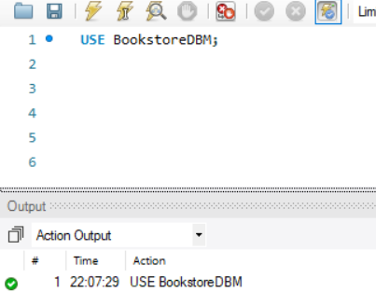

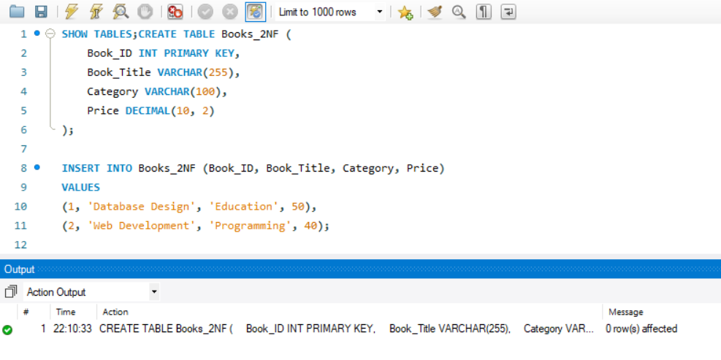
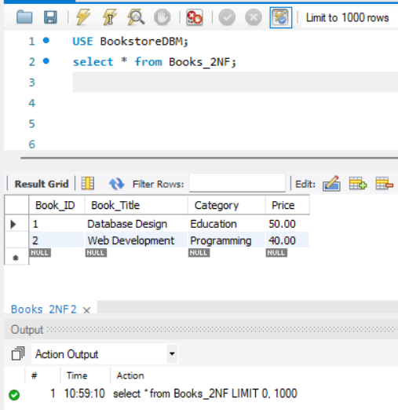

Authors Table

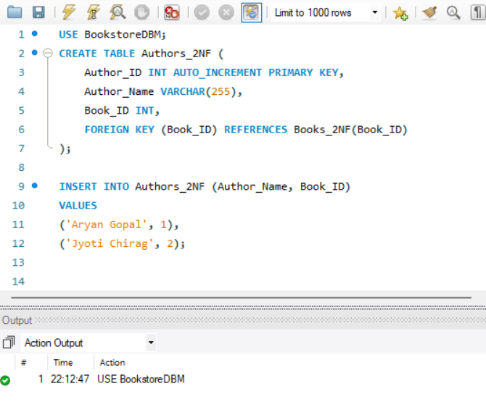
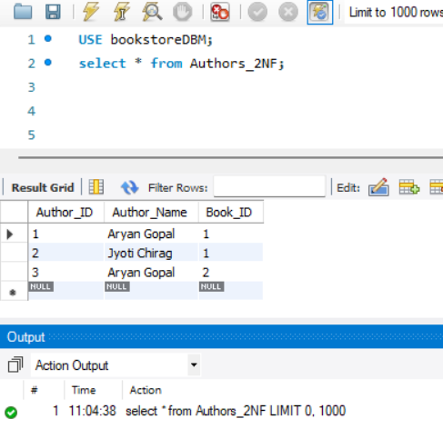
Publishers Table
This table stores publisher details that depend solely on Book_ID.
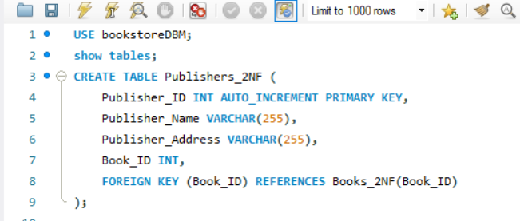
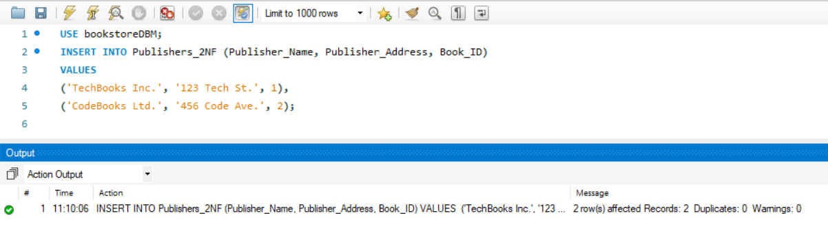

(c) Normalize to 3NF: Normalize the tables to Third Normal Form (3NF) by removing transitive dependencies. Write the final schema with separate tables for Books, Authors, and Publishers. Include primary keys and foreign keys.

To normalize the tables to Third Normal Form (3NF), we must ensure:
The table is already in Second Normal Form (2NF).
There are no transitive dependencies, i.e., non-key attributes do not depend on other non-key attributes.

In the Publishers_2NF table, Publisher_Address is dependent on Publisher_Name and not directly on Book_ID.
This creates a transitive dependency:
Book_ID → Publisher_Name → Publisher_Address
Steps to Remove Transitive Dependencies
To remove transitive dependencies:
- Split the Publishers_2NF table into two tables:
  - A table for Publisher details.
  - A table to link Books to their respective Publishers.
- Ensure that each table has a single primary key and no non-key attribute depends on another non-key attribute.

Table 1: Books_3NF
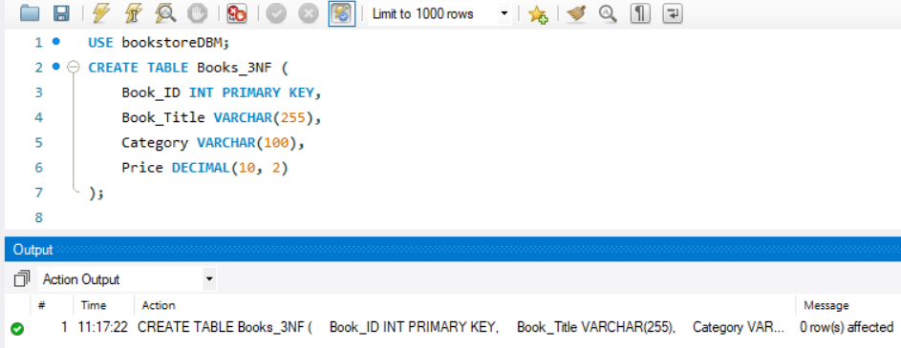

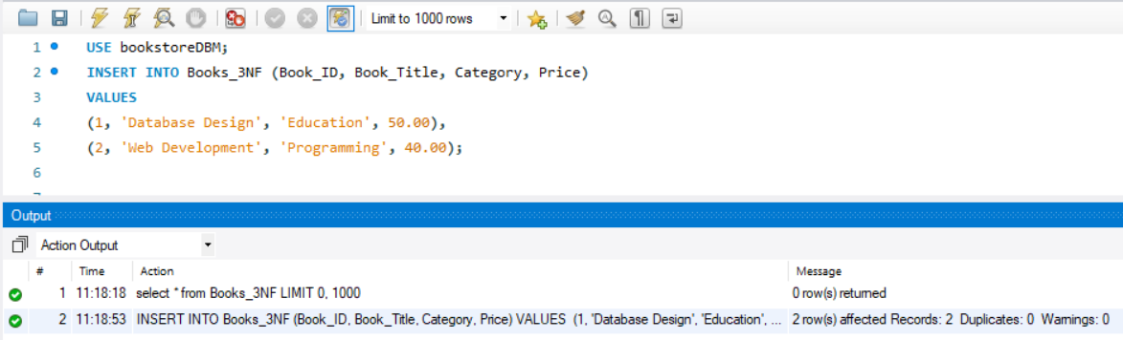

Table 2: Authors_3NF
Stores author details and their association with books.
- Primary Key: Author_ID
- Foreign Key: Book_ID
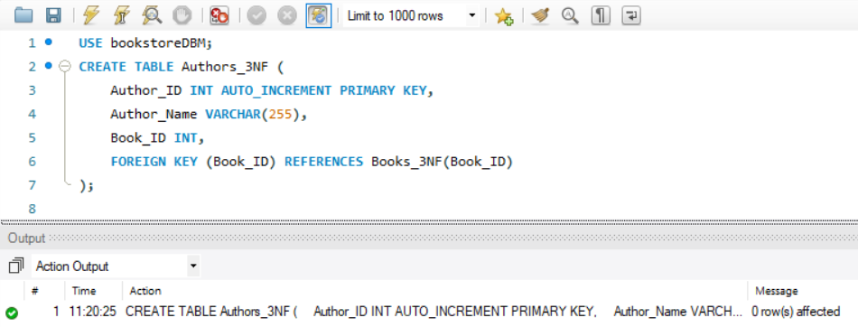
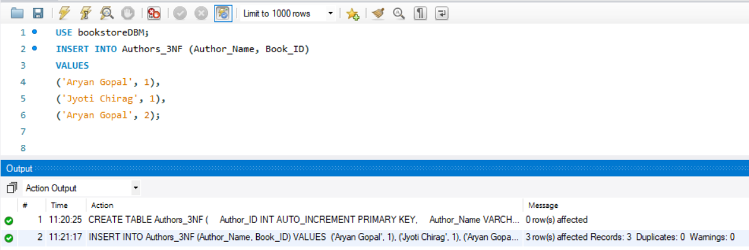

Table 3: Publishers
Stores publisher details.
- Primary Key: Publisher_ID

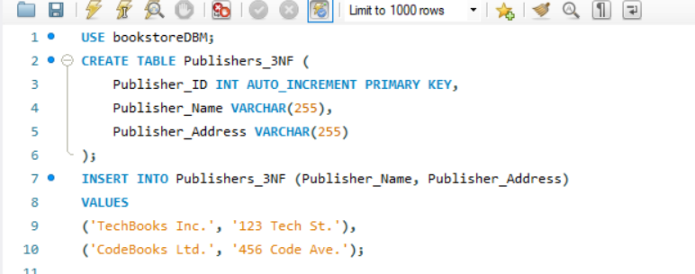
Table 4: Book_Publishers
Links books to their respective publishers.
- Primary Key: Book_ID
- Foreign Keys: Book_ID, Publisher_ID
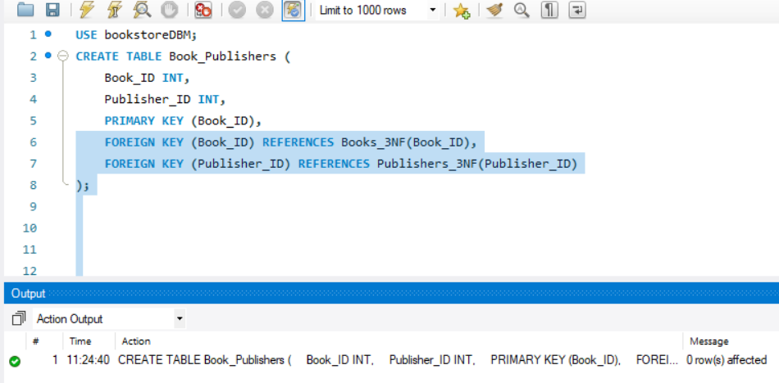
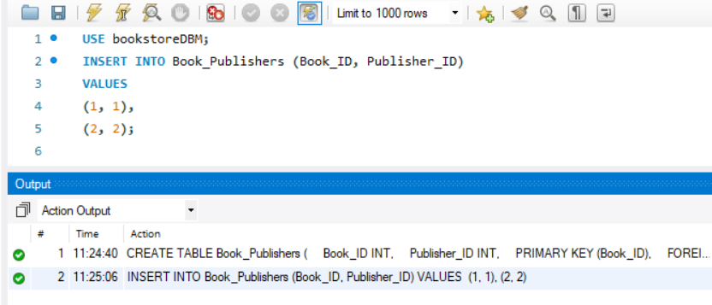

(d) Sample Data Insertion: Provide at least three SQL INSERT statements for each of the normalized tables you created. Ensure that the data reflects realistic entries for books, authors, and publishers.
Now the below are some SQL INSERT statements for each table created during normalization to 3NF.
Books_3NF Table
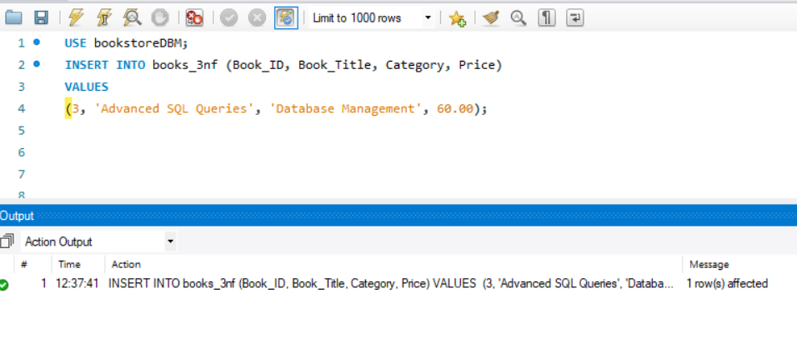
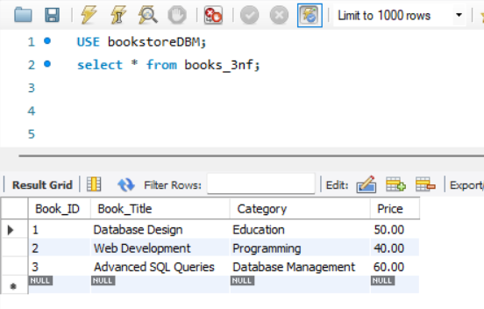

Authors_3NF Table
The Authors_3NF table stores authors and their association with books.
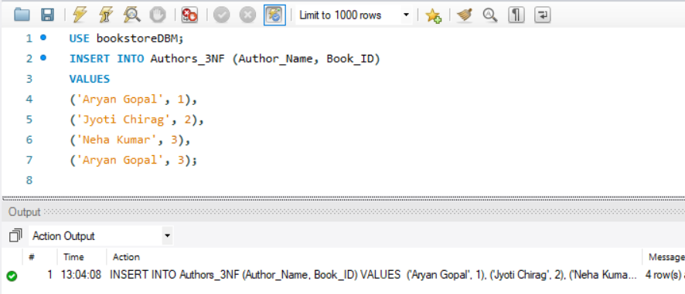

Publishers_3NF Table
The Publishers_3NF table stores publisher details.

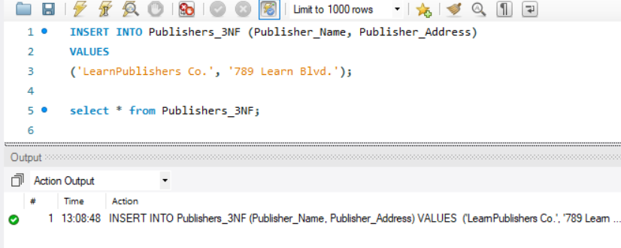

Output:
The queries was successfully executed

